Scavenger Hunt: Nature in Your Home

You don’t always need to go outside to find nature all around you. Many of the items in your home come from natural sources. Just look around! You may see furniture made from trees or honey from bees. Can you find of any other items made from nature?

Something that came from an animal
Something made from a tree’s bark or wood

Something growing

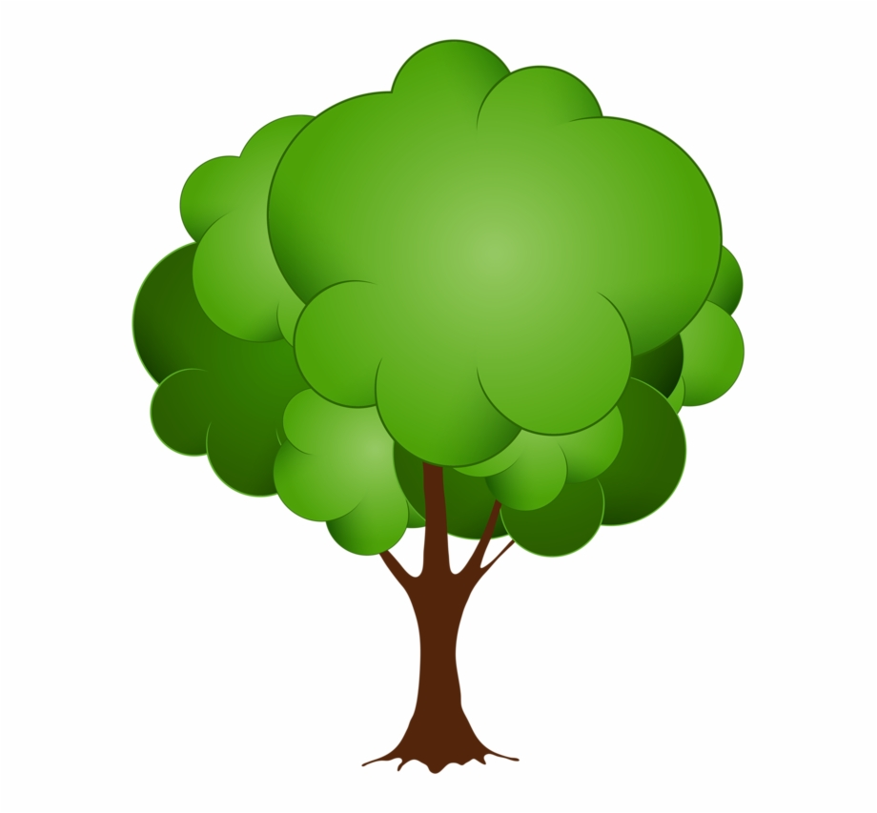

Something made from rock or soil
Something you can eat
Something that grew from a seed

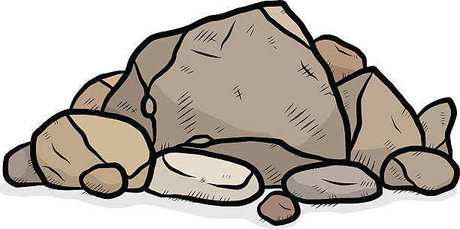

Something made from the leaves of a plant
Something that contains water
Something alive

Directions: See if you can find items around your home that come from nature in each of the above categories. Some items may be able to fit in more than one box!

How many items in your home did you find that come from natural sources? Were any categories difficult to find?

Did it surprise you how many items in your home came from nature? Maybe you already knew that paper comes from trees, but did you know salad dressing does too? Check out this video to see how many things you use every day actually come from trees!

Since so much of what we use in our homes comes from nature, it is very important we look after our environment. Reusing materials is a great way to keep items in your home, instead of throwing them away.

Check out this link for some great recycled craft ideas:
- https://www.weareteachers.com/earth-day-crafts-classroom-activities/
- For more earth-friendly ideas, check out Walking Mountain’s Earth Day Activities

Bonus Challenge!
Choose one item you found on your scavenger hunt, and draw its journey from nature to your home.

